Book Week 2018 QR Challenge!
Picture Books
Question 1
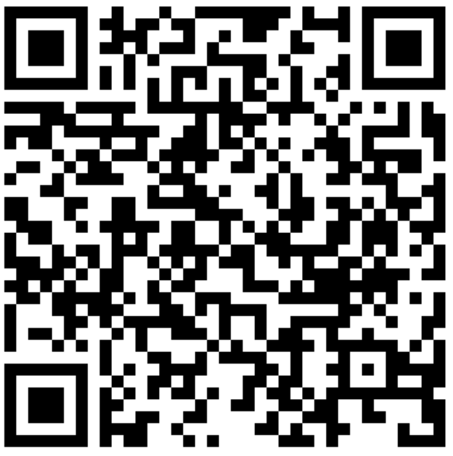

Book Week 2018 QR Challenge!
Picture Books
Question 2
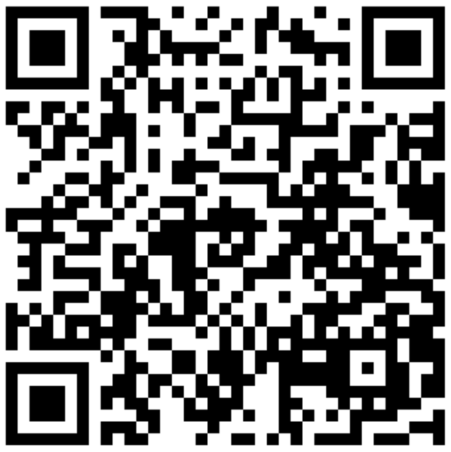

Book Week 2018 QR Challenge!
Picture Books
Question 3
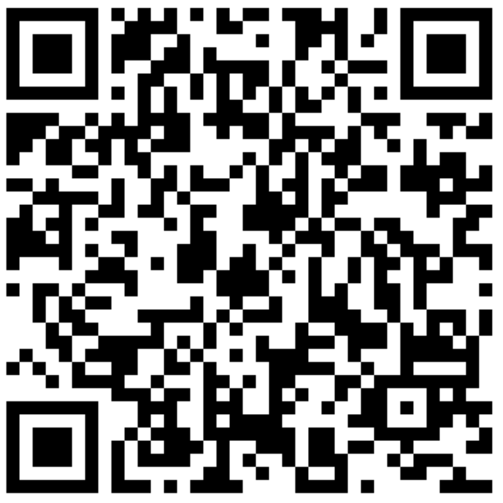

Book Week 2018 QR Challenge!
Picture Books
Question 4
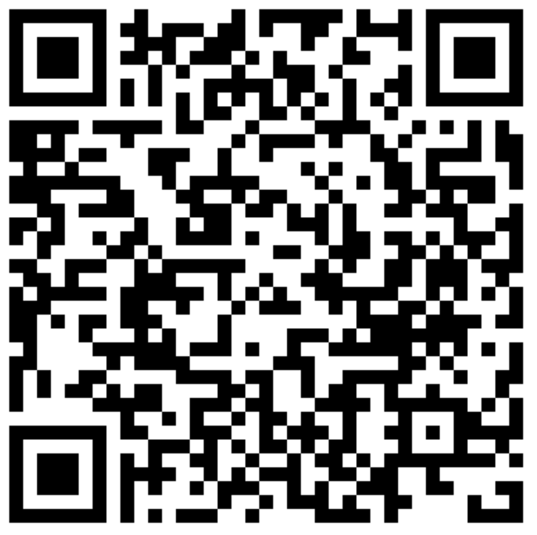
Book Week 2018 QR Challenge!
Picture Books
Question 5

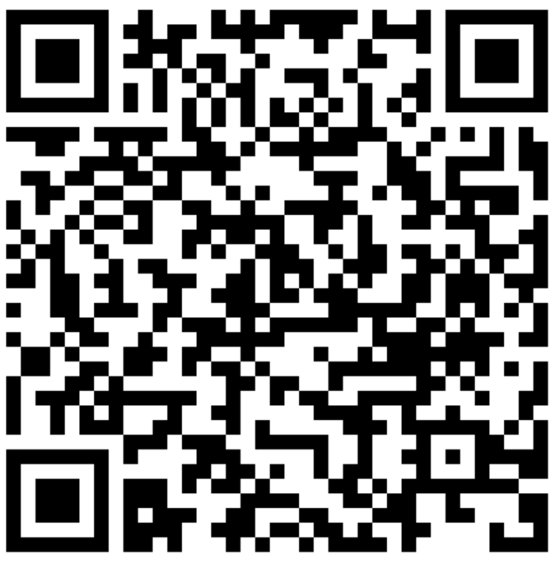
Book Week 2018 QR Challenge!
Picture Books
Question 6

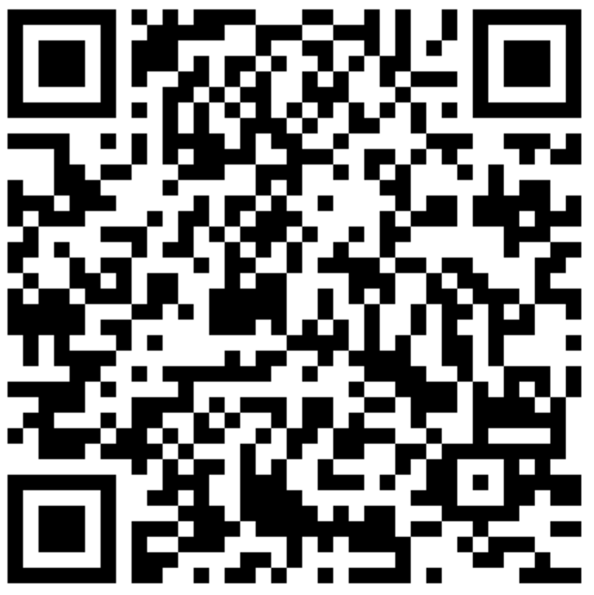
Picture Books Answer sheet
Name: ………………………………………………………………………………………………………………………….. Class: …………………………..……
Question 1 ……………………………………………………………………………………………………………………………………………………………………………….
Question 2 ……………………………………………………………………………………………………………………………………………………………………………….
Question 3 ……………………………………………………………………………………………………………………………………………………………………………….
Question 4 ……………………………………………………………………………………………………………………………………………………………………………….
Question 5 ……………………………………………………………………………………………………………………………………………………………………………….
Question 6 ……………………………………………………………………………………………………………………………………………………………………………….
Picture Books Answer sheet
Name: ………………………………………………………………………………………………………………………….. Class: …………………………..……
Question 1 ……………………………………………………………………………………………………………………………………………………………………………….
Question 2 ……………………………………………………………………………………………………………………………………………………………………………….
Question 3 ……………………………………………………………………………………………………………………………………………………………………………….
Question 4 ……………………………………………………………………………………………………………………………………………………………………………….
Question 5 ……………………………………………………………………………………………………………………………………………………………………………….
Question 6 ……………………………………………………………………………………………………………………………………………………………………………….
Picture Books Treasure Hunt
Questions and answers:

1. In what book do they smell the eucalyptus leaves?
A Walk in the Bush

2. What book tells a true story of immigration to Australia?
Ten Pound Pom

3. What story is based on a Tchaikovsky ballet?
Swan Lake

4. In what book does the character find a piece of forest?
Florette

5. In what story is a character called Gumboots?
The Great Rabbit Chase

6. What book features a Southern Boobook?
Mopoke

