Exact phrase “.......”
Search an exact phrase

“Murray River turtle”

“Eastern saw shelled turtle”

Exclude a word -
Add a - to remove a word from your search

Turtle -freshwater

turtle adaptation -wikipedia

Wild card *
Add a * to search for missing word in an exact phrase or at the end of a word to extend the search term

“wombat who * stars”

Tagging Turtle “* reef”

bird* (this would search for bird, birds, birdlife, birdbath)

Search within a domain site:
To search for a type of site add site:

site:.gov (search for a Government site)

site:.edu (search for an Educational site)

site:.au (search for a site in Australia)

Search within a website site:
To search within a website add site:

Tagging sharks site:australianmuseum.net.au/
(search about tagging sharks only in the Australian Museum website)

Adaptation site:nationalgeographic.com.au
(search about adaptation only in the National Geographic Australia website)

Reverse Image Search
To search information about an image:

- Right-click an image and select Copy image URL
- Go to Google Images
- Click Paste image URL and paste the copied URL
- Click Search by image

Search Google News - select search tools
Search for news, select News and open the Search tools to select Australia:

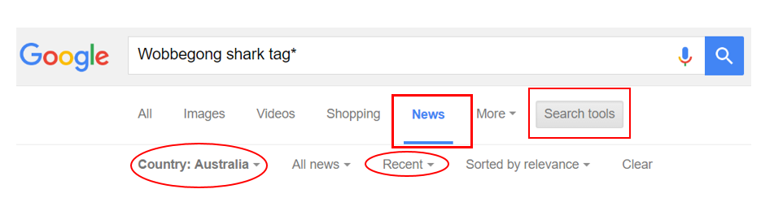

Search Google Advanced
Search Google Advanced and add your search terms to the filters:

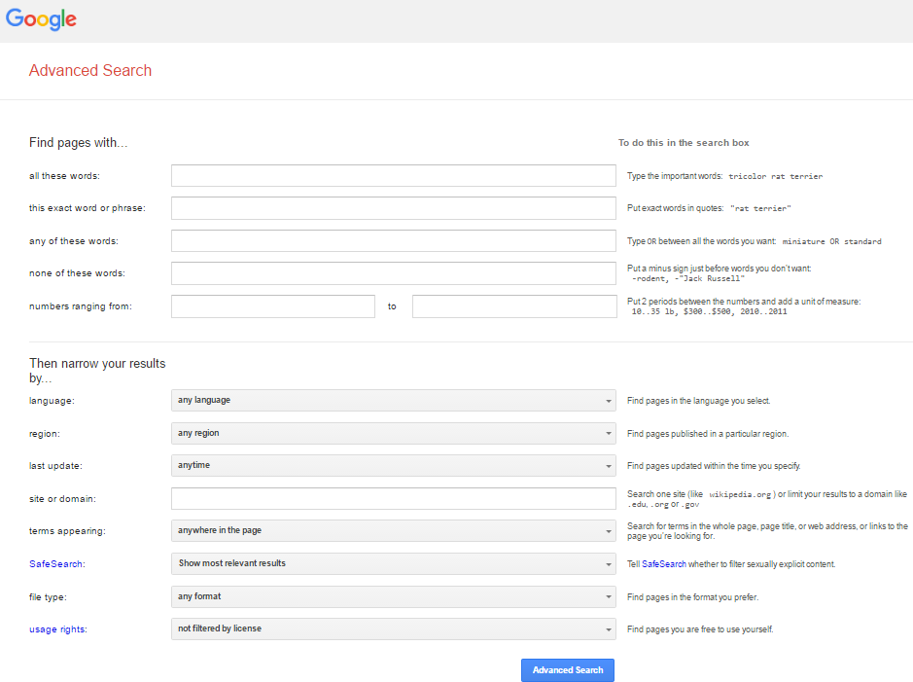

Try this: What can you find out about birdlife in Kati Thanda?

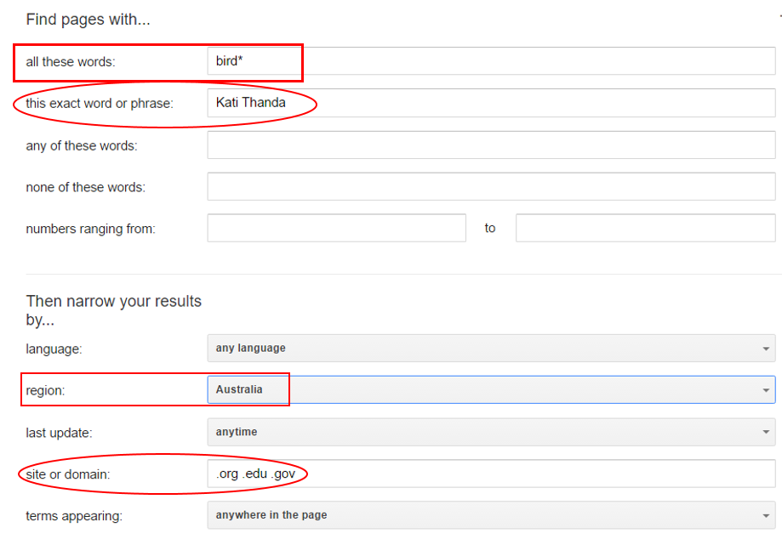

Search Google Image Search
Search Google Images and select Search tools, select size, colour, type of image:

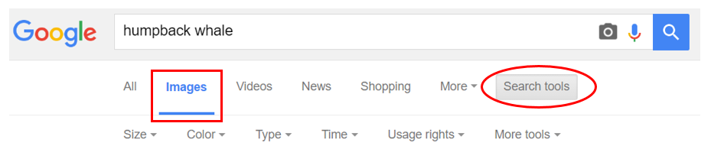

Search Google Advanced Image Search
Search Google Advanced Image Search and add your search terms to the filters:
