International
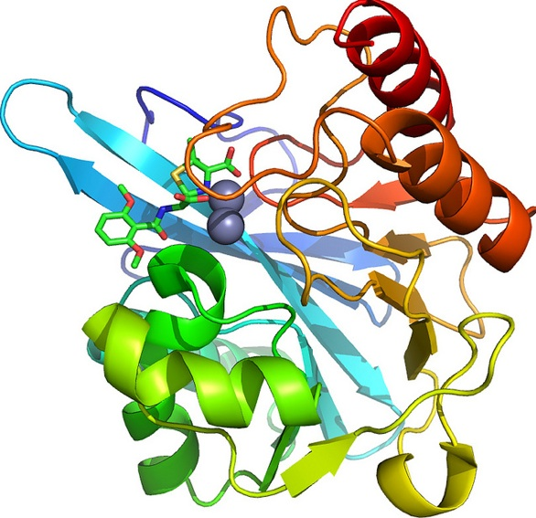
Year of Crystallography

Image source: https-//flic.kr/p/dACqvj
Crystalline Structure of Ice

http://www.its.caltech.edu/~atomic/snowcrystals/ice/ice.htm

Learn about Crystals
with BrainPOP
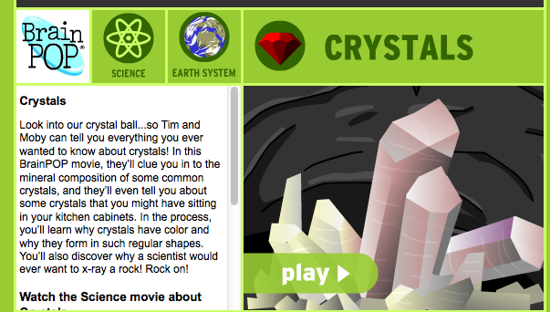

Diamond
Structure
(Molymod)

http://www.chemguide.co.uk/atoms/structures/giantcov.html
Growing Crystal Gardens

http://www.msm.cam.ac.uk/phase-trans/2002/crystal/a.html

Fluorescent
Minerals

http://geology.com/articles/fluorescent-minerals/

What’s it all about?
Watch this clip to learn more!
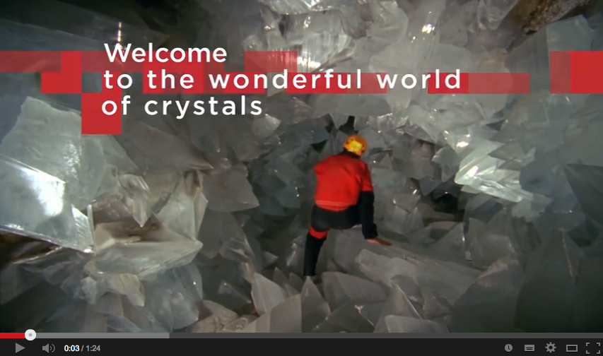
http://youtu.be/m2maeeA9z84

Watch a crystal garden grow!

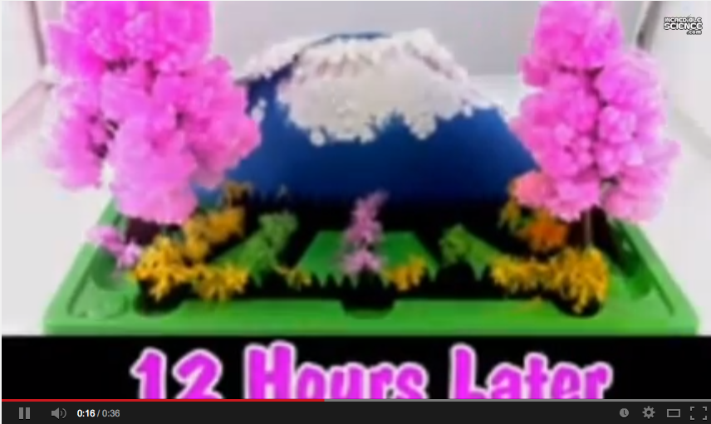

http://youtu.be/G9OyEiGmqms

Watch an experiment to form hot ice!

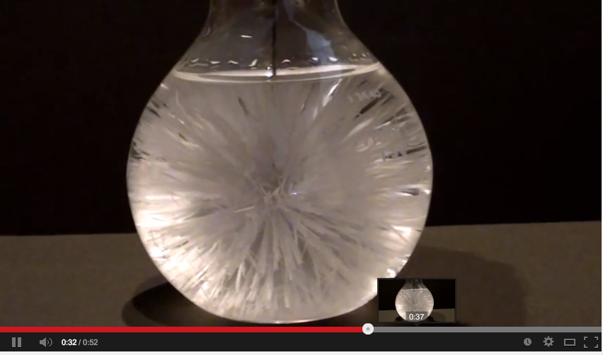
http://youtu.be/BLq5NibwV5g

